Web Development Assignment Answers
- Difference between Frontend, Backend, and Full-Stack Development Frontend: Builds the user interface using HTML, CSS, and JavaScript. Example: Amazon product page.
Backend: Handles server logic, authentication, and database operations using languages like Java, Python, or Node.js. Example: Processing an online payment.
Full-Stack: Develops both frontend and backend. Example: Building a complete e-commerce website.

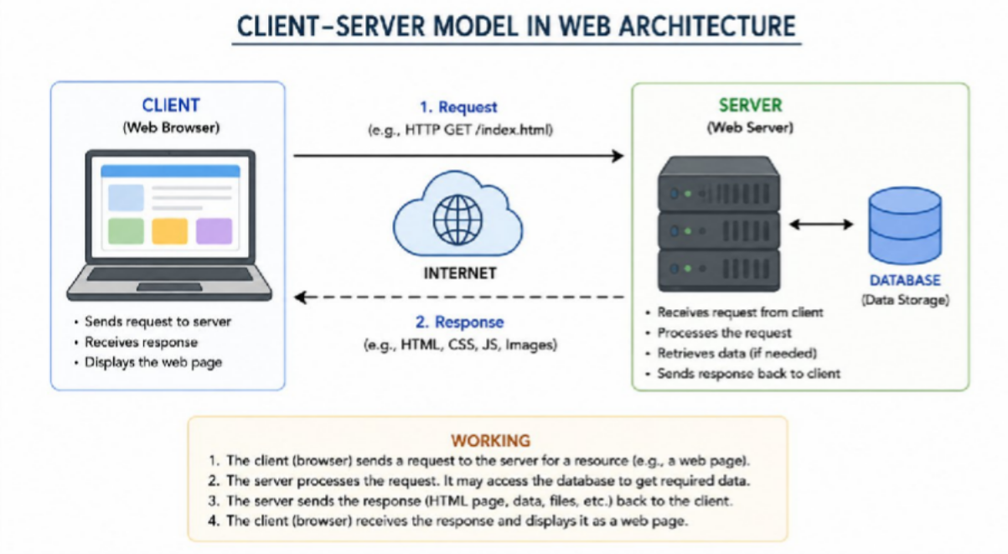
Client-Server Model Diagram
- How a Browser Requests and Displays a Web Page
- User enters a URL.
- Browser sends an HTTP request to the server.
- Server processes the request and fetches data if needed.
- Server returns HTML, CSS, and JavaScript.
- Browser renders the page for the user.

Tools Required for Web Development
  - VS Code – Code editor.
  - Web Browser – Test webpages.
  - Node.js – JavaScript runtime.
  - Git – Version control.
  - Live Server Extension – Live preview.
  - Chrome DevTools – Debugging.

What is a Web Server?
A web server stores and delivers web pages to users through HTTP/HTTPS. Examples: Apache HTTP Server, Nginx, Microsoft IIS, Node.js Express.

Roles in a Project
Frontend Developer: Designs user interface.
Backend Developer: Develops server-side logic and APIs.
Database Administrator (DBA): Manages databases, security, backups, and performance.

VS Code Installation
Install VS Code, then install these extensions:
  - Live Server
  - HTML CSS Support
  - JavaScript (ES6) snippets
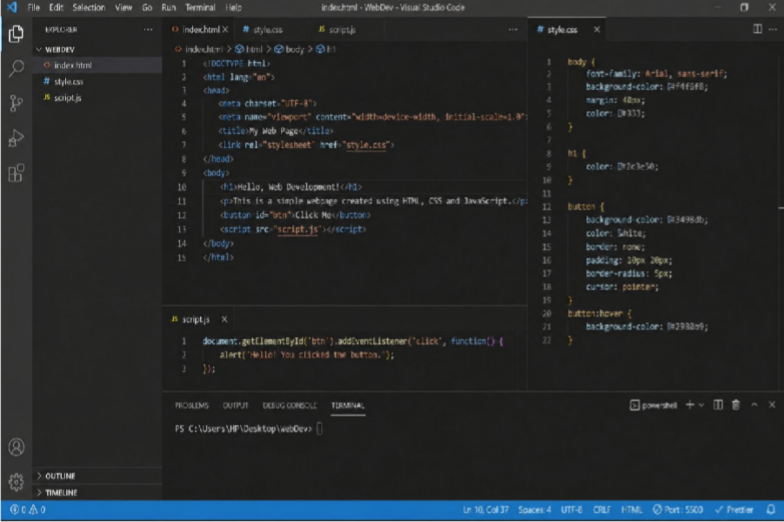
Configure by creating HTML, CSS, and JS files and opening them with Live Server.

Static vs Dynamic Websites
Static Website: Fixed content. Example: Portfolio website.
Dynamic Website: Content changes based on user interaction or database. Example: Facebook or Amazon.

Five Web Browsers and Rendering Engines
Google Chrome – Blink Microsoft Edge – Blink Mozilla Firefox – Gecko

Safari – WebKit Opera – Blink

Blink: Fast and Chromium-based. Gecko: Mozilla's independent engine.
WebKit: Apple's rendering engine optimized for Safari.
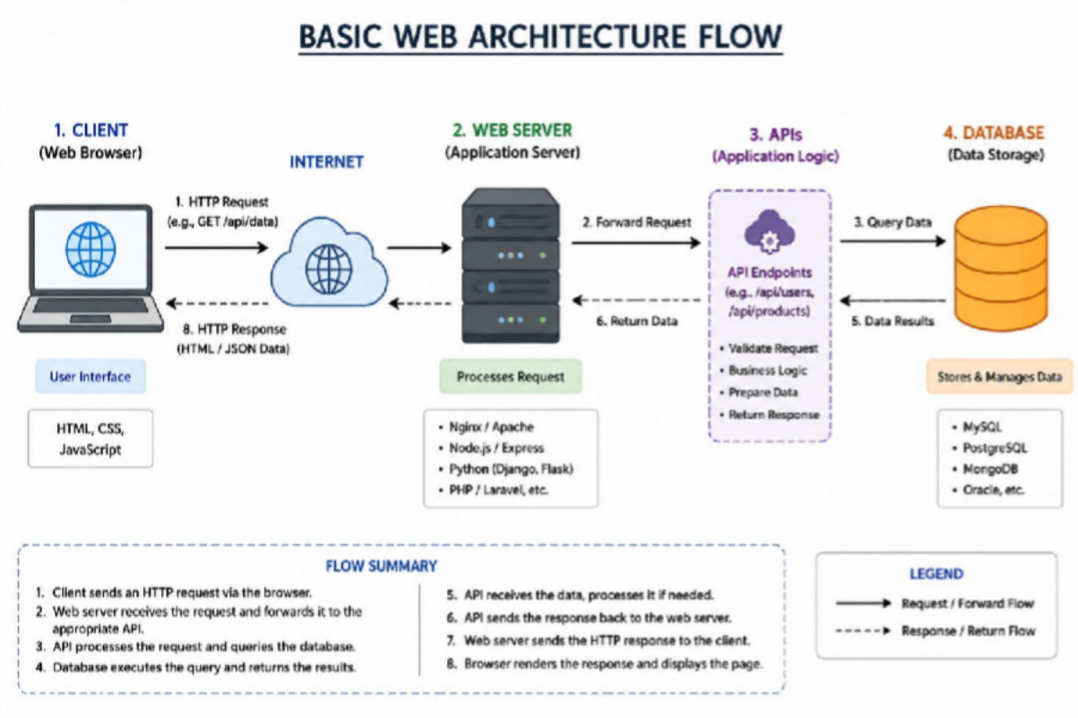
- Basic Web Architecture Diagram

